**Chapter 3**

**Information Gathering**

**3.1 Introduction**

Information gathering is an indispensable and substantial part of analyzing a system. To know, analyze or discuss about a system, firstly the information about the system should be found out. Information gathering requires a person who knows what information is to be collected, where these would be found and in which way the information is to be gathered. To collect information, the art of information gathering is to be mastered. This means that information gathering is not an easy or routine work. Proper preparation, experience and training provides fruitful information gathering.

Though information gathering does not require any standard rule, it is important to do it accurately, methodologically, under right conditions and without minimum interruption to the user personnel. Some important tools are used to gather information. By proper use of these tools, the information gathering becomes easy, methodological and required information can be collected from various sources.

Here we are going to analyze the system NESCO or Northern Electricity Supply Company. The required information to analyze the system using four tools have been collected.

**3.2 Different tools used in Information gathering**

All the information collected from the organization are presented in detail in this section using different tools.

**3.2.1 Forms, documents and statistical chart of NESCO**

First tool for gathering information is collecting information from the existing system, forms, documents or any statical explanation of the system. As the problems are more or less same for any system. We can get a clear idea about the ongoing processes of the organization from the forms and documents.

Several forms and documents are collected from which we can get some information about the working process of NESCO. These are the wiring inspection report in section 3.2.1.1, wiring certificate form in section 3.2.1.2, disconnection form in section 3.2.1.3, reconnection form in section 3.2.1.4, meter exchange form in section 3.2.1.5, officer’s evaluation form in section 3.2.1.6, application form in section 3.2.1.7 and load calculation document in section 3.2.1.8 respectively.

**3.2.1.1 Wiring Inspection Report**

Wiring Inspection Report is the form to take new connection in any residential area or any industries. It elaborately discusses about the connection and the wiring system.

Who is the applicant, how is the wiring condition, how many meters, how many phases, the address of the user, the transformer pole number all things are combined here in the report.

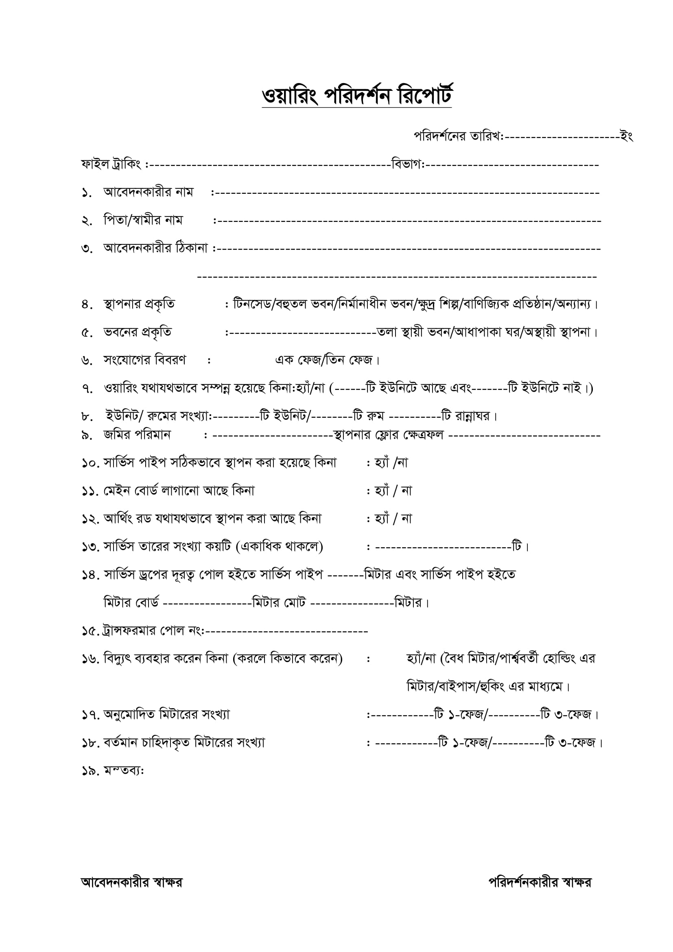The figure 3.2.1.1(a) shows the wiring inspection form in detail.

Figure 3.2.1.1 Wiring Inspection Report

**3.2.1.2 Wiring Certificate Form**

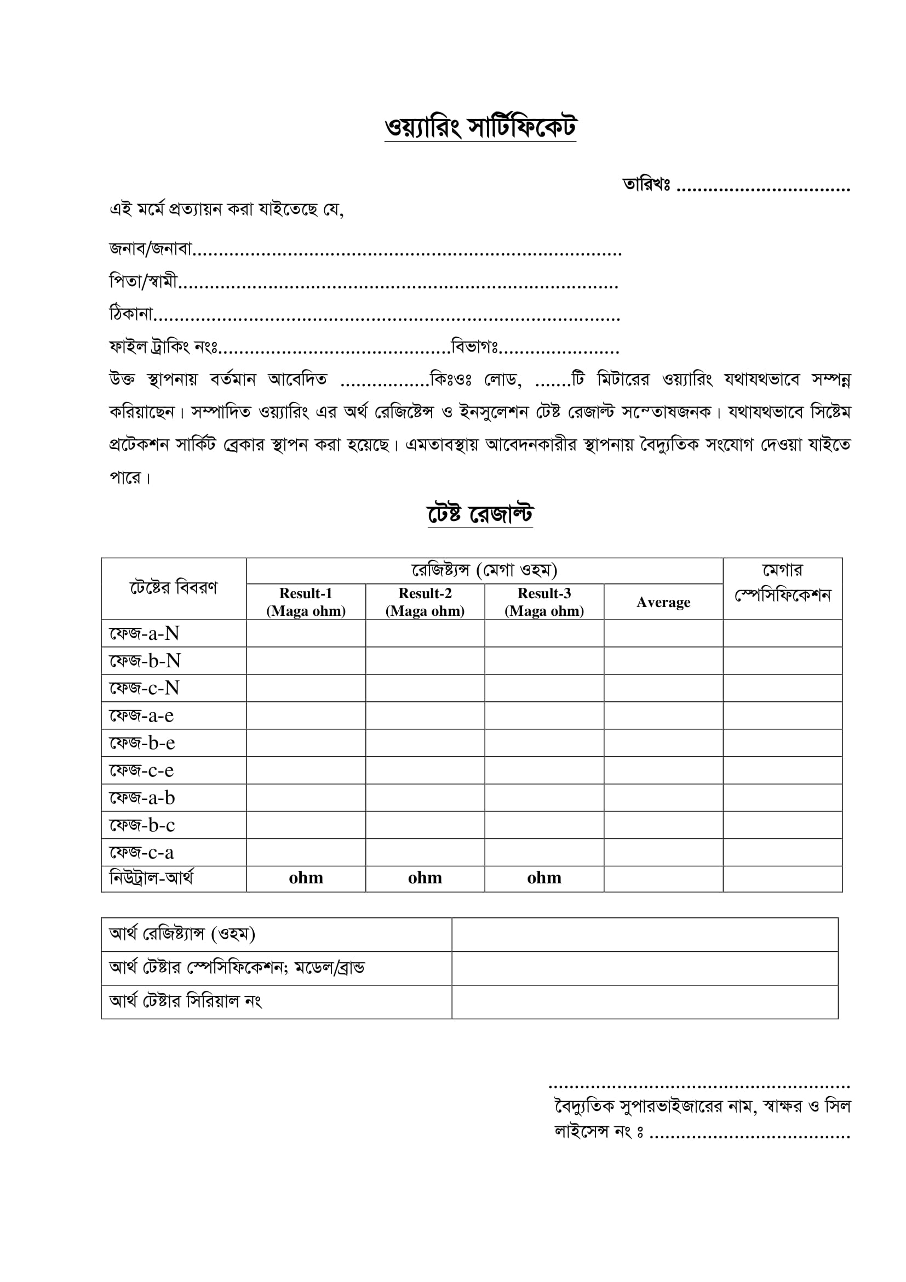Wiring certificate form contains the ownership of meter by the people and the connections and wiring system are briefly discussed in the form. The test result after the wiring test is also attached in the form. Figure 3.2.1.2 contains the wiring certificate.

Figure 3.2.1.2 Wiring Certificate Form

**3.2.1.3 Disconnection Form**

To disconnect any electricity connection or meter, a form is fill up by the user which contains the details of meter, customer number, the reason of disconnection etc. After applying is checked and approved by the authority of NESCO.

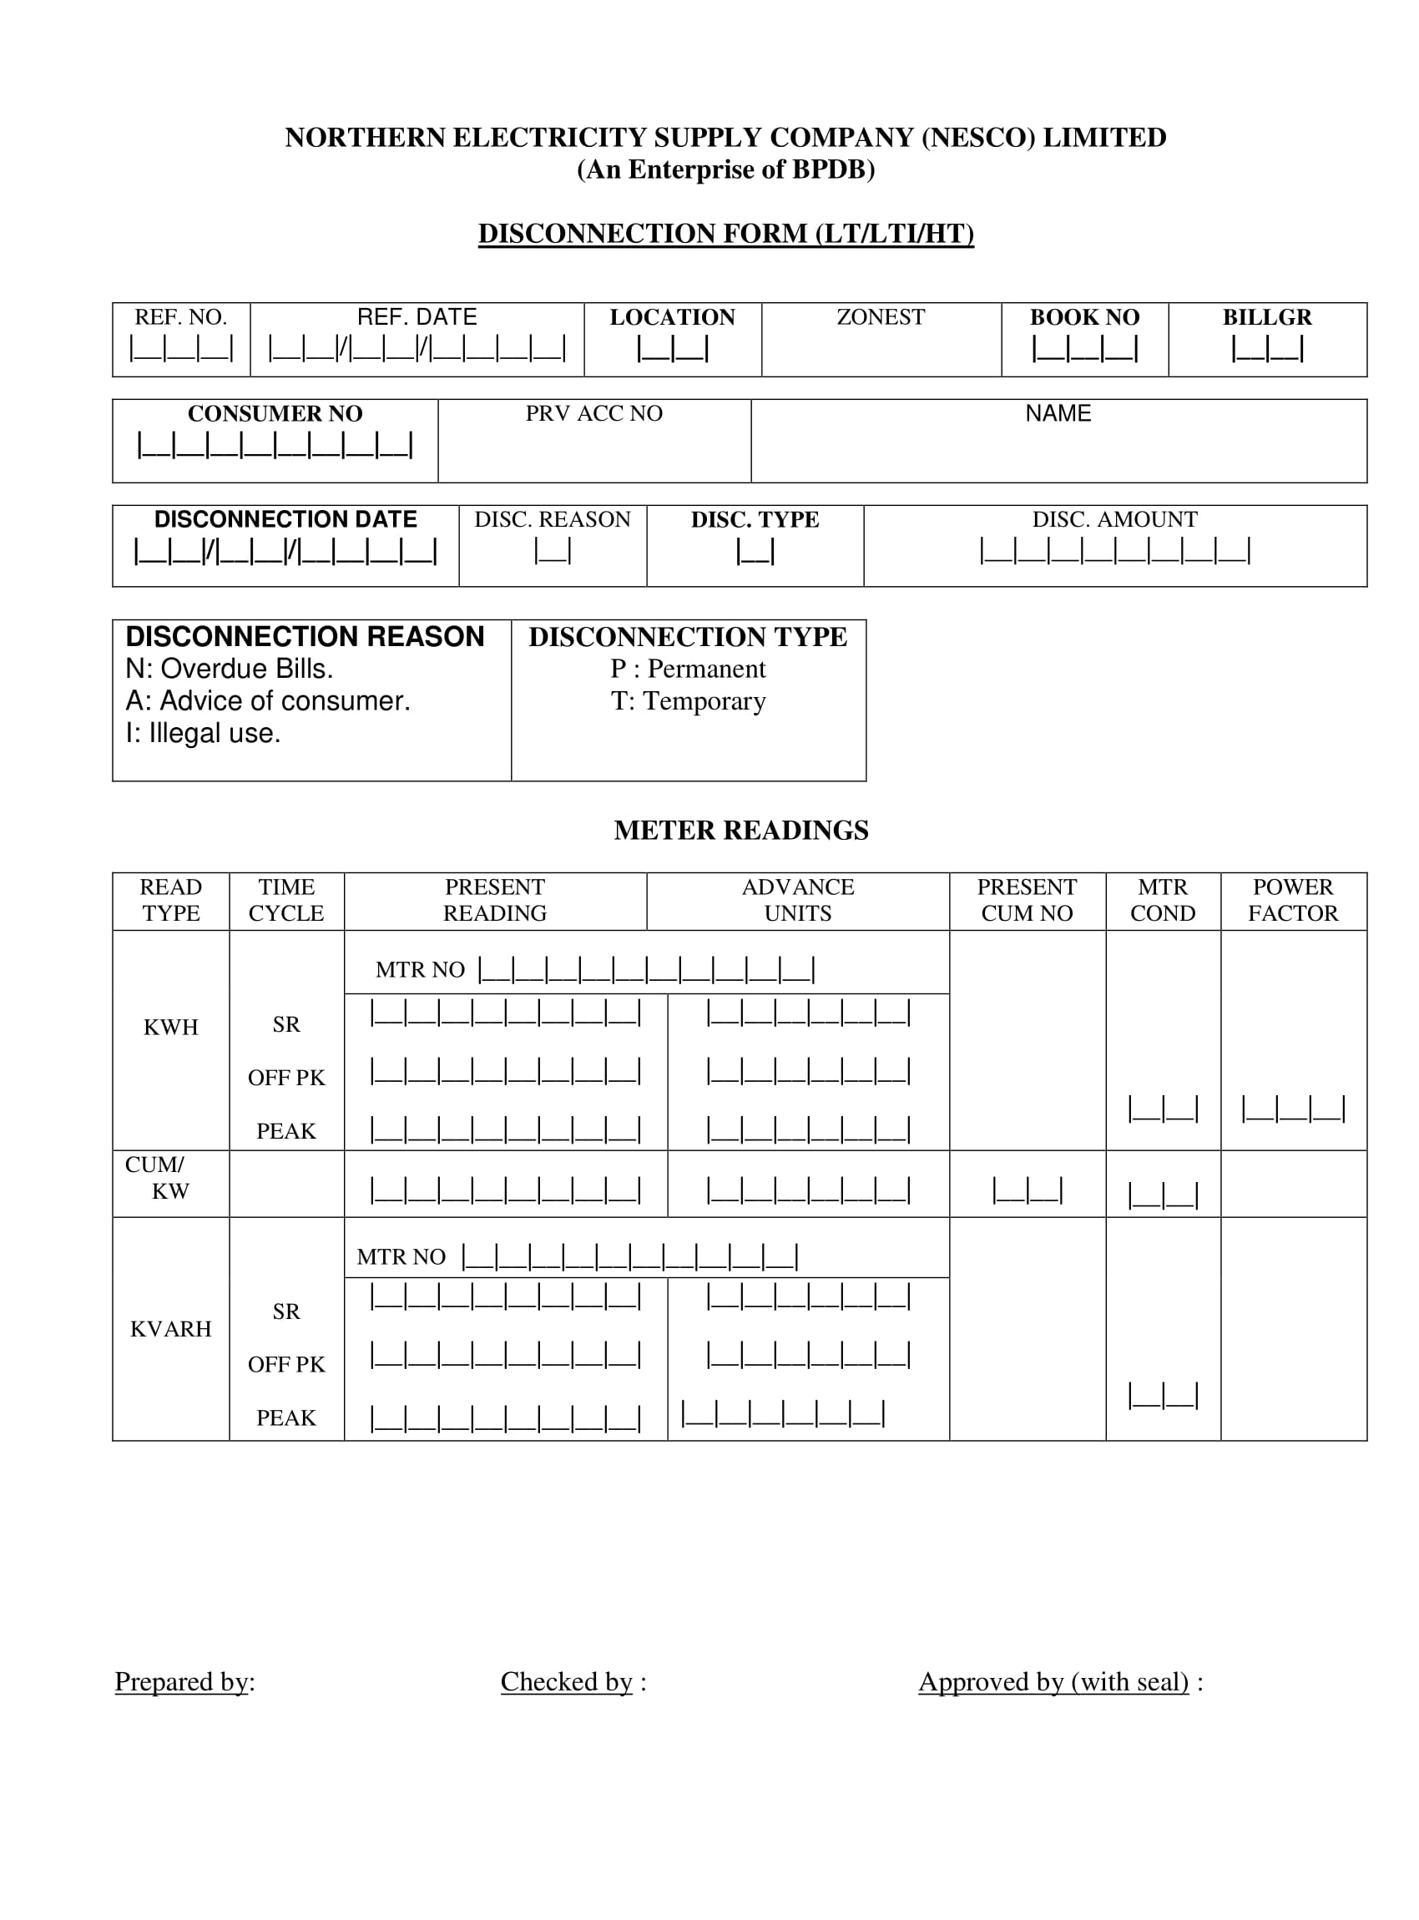Figure 3.2.1.3 contains the disconnection form.

Figure 3.2.1.3 disconnection form

**3.2.1.4 Reconnection Form**

If connection is expired or cut down for any reason, then this reconnection form is used to again connect the meter. After applying is checked and approved by the authority of NESCO.

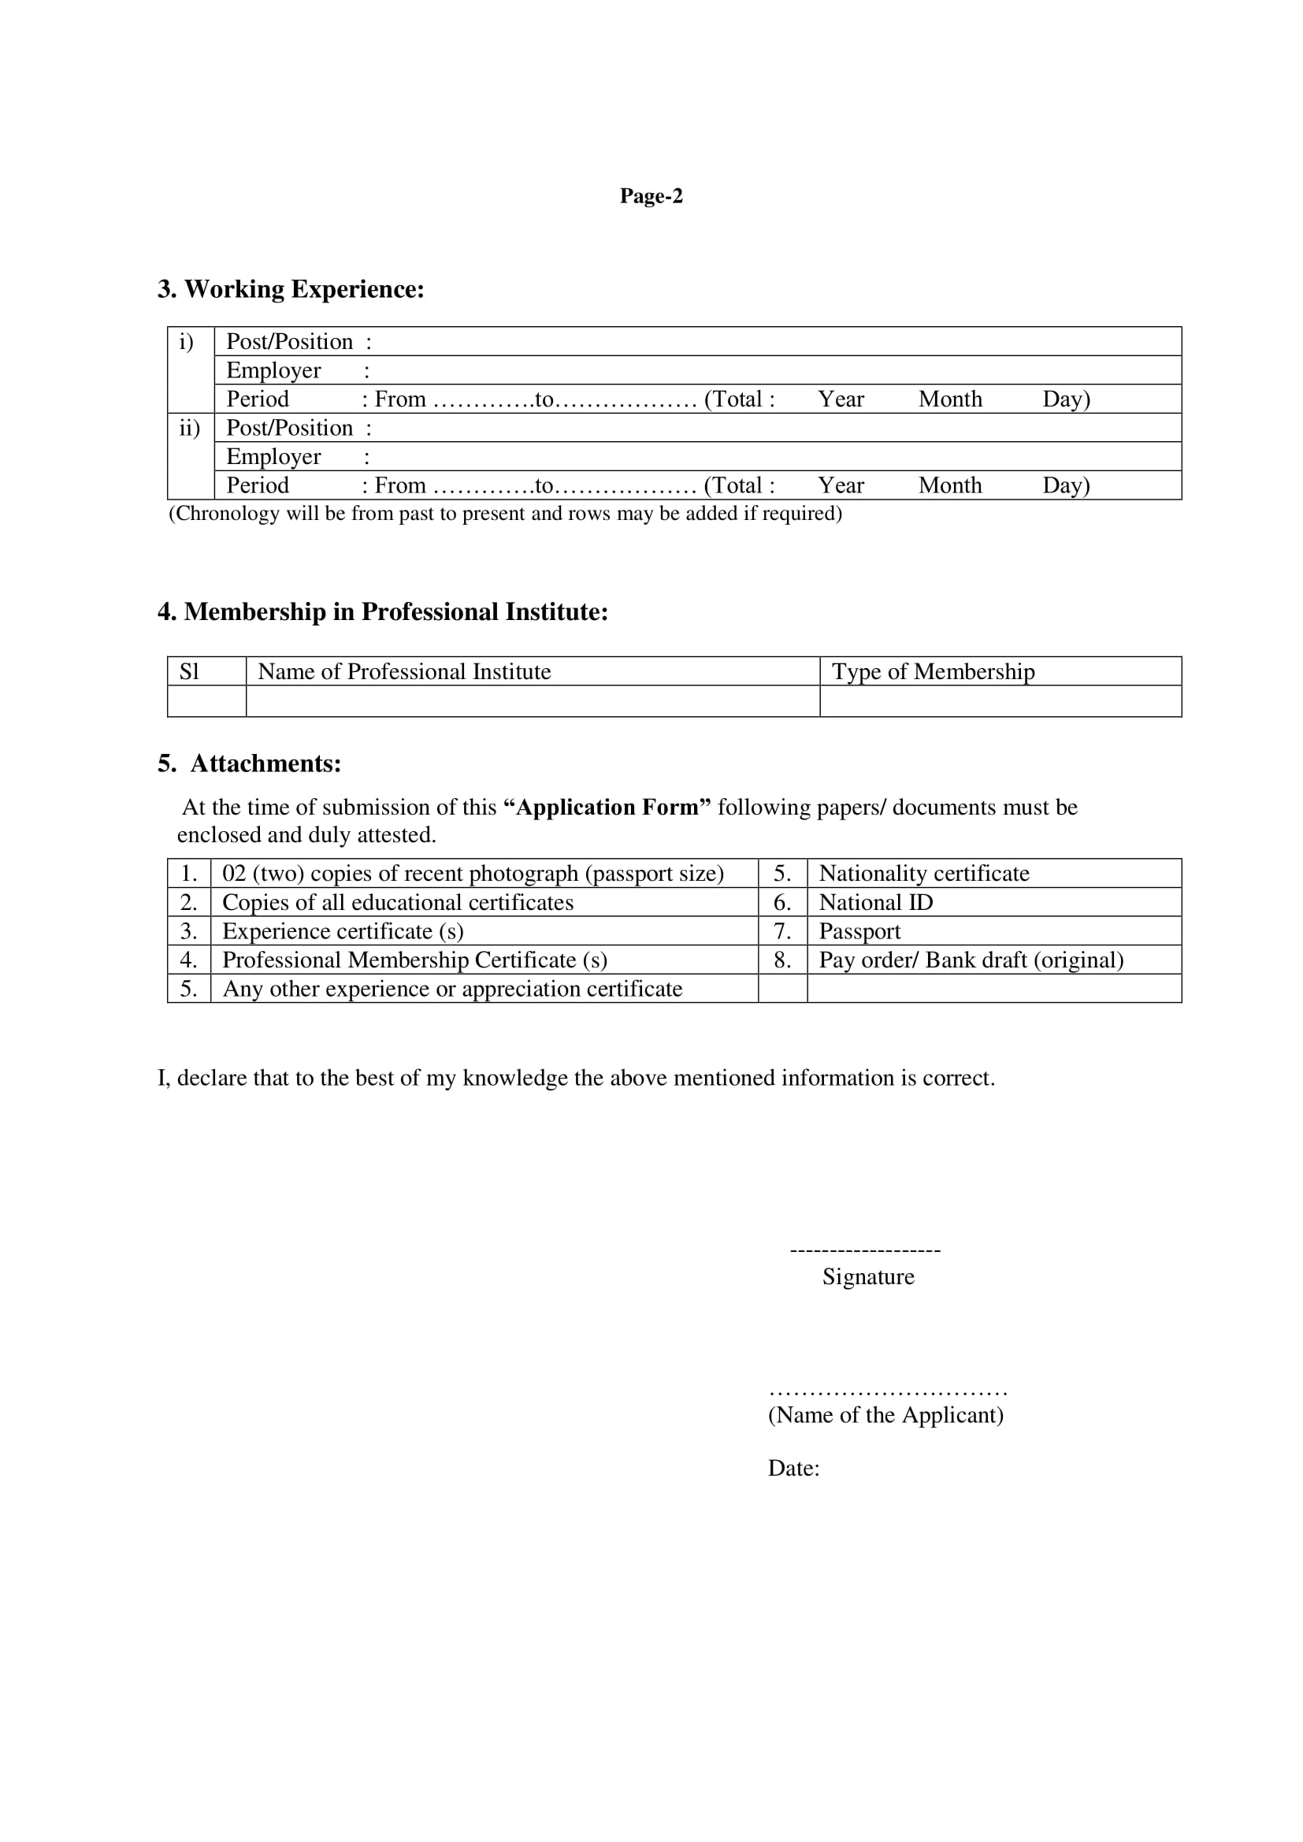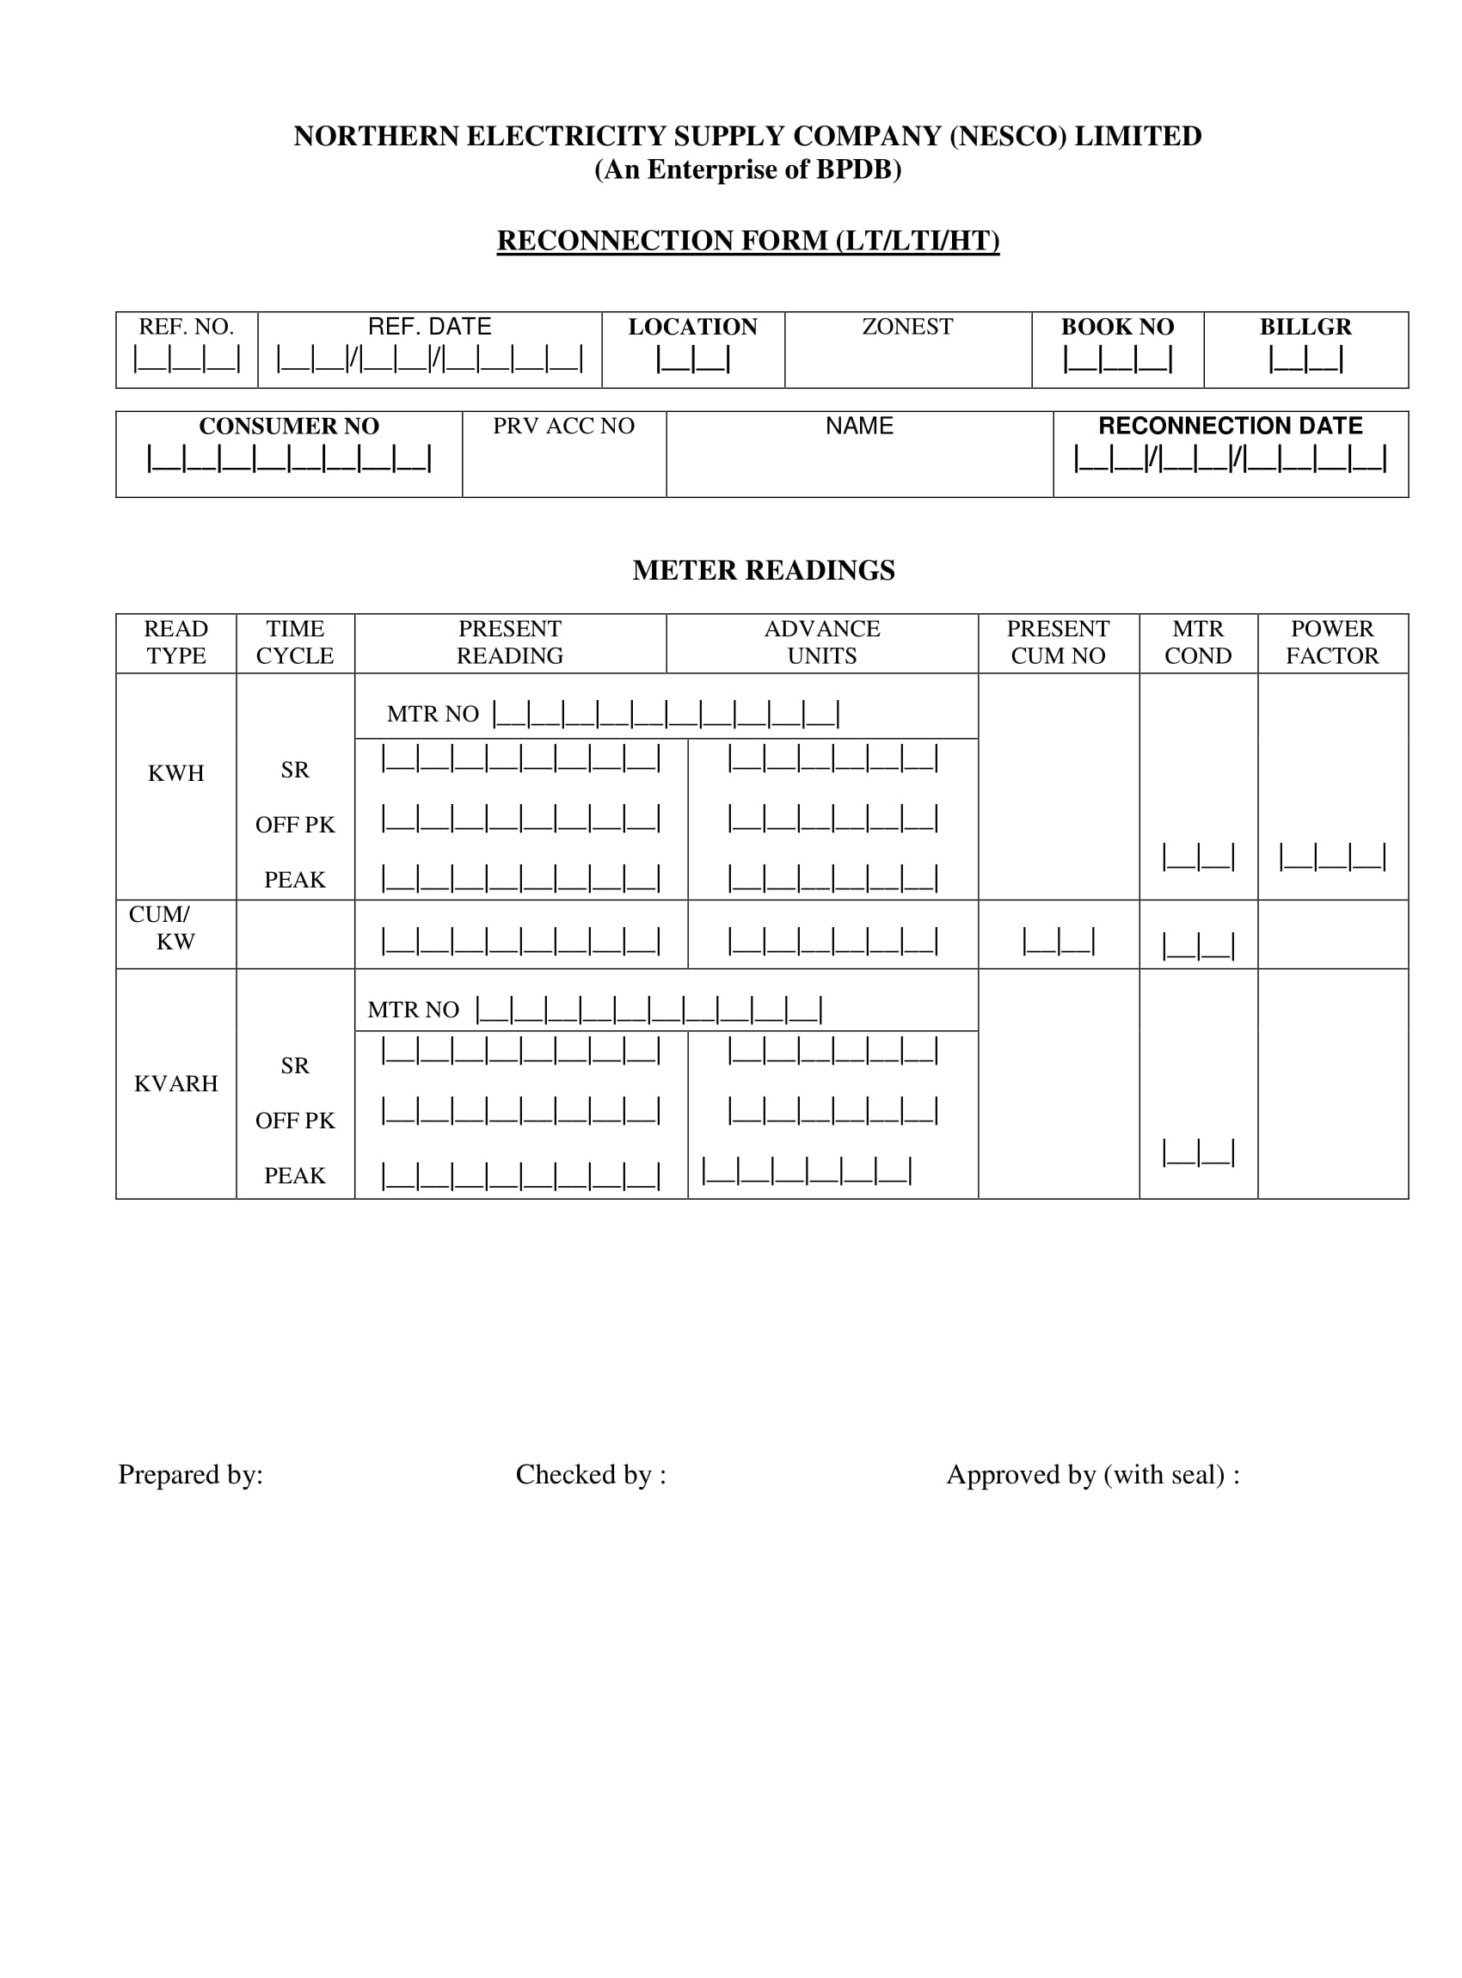Figure 3.2.1.4 contains the reconnection form.

Figure 3.2.1.4 reconnection form

**3.2.1.5 Meter Exchange Form**

The faulty meters are needed to be exchanged with the new one. To exchange meters this form is filled up which contains the details of the old meter, new meter and the customer id or number who is willing to exchange etc.

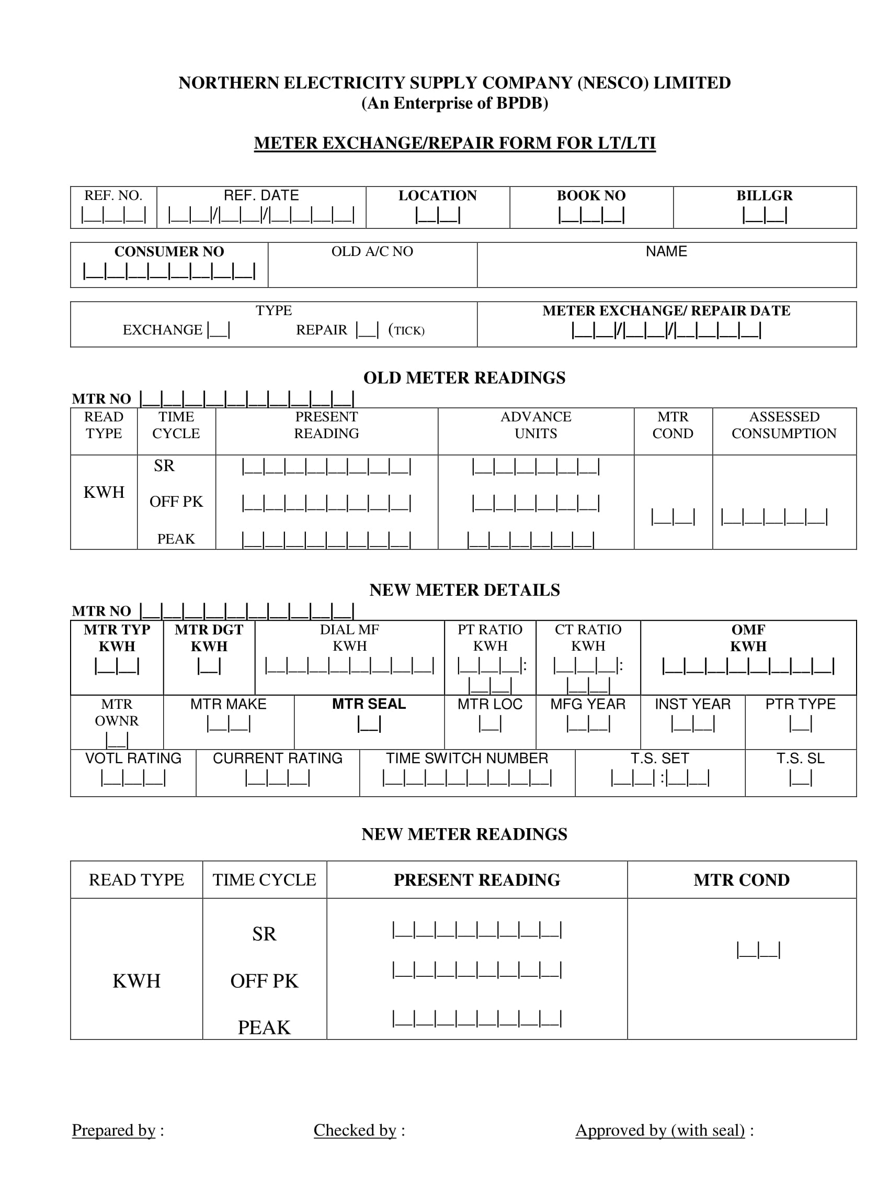Figure 3.2.1.5 contains the meter exchange form.

Figure 3.2.1.5 meter-exchange form

**3.2.1.6 Officer’s Evaluation Form**

By the use of this form, the evaluation of the officials is done depending on their discipline, sincerity to job, personality, service and all other parameters.

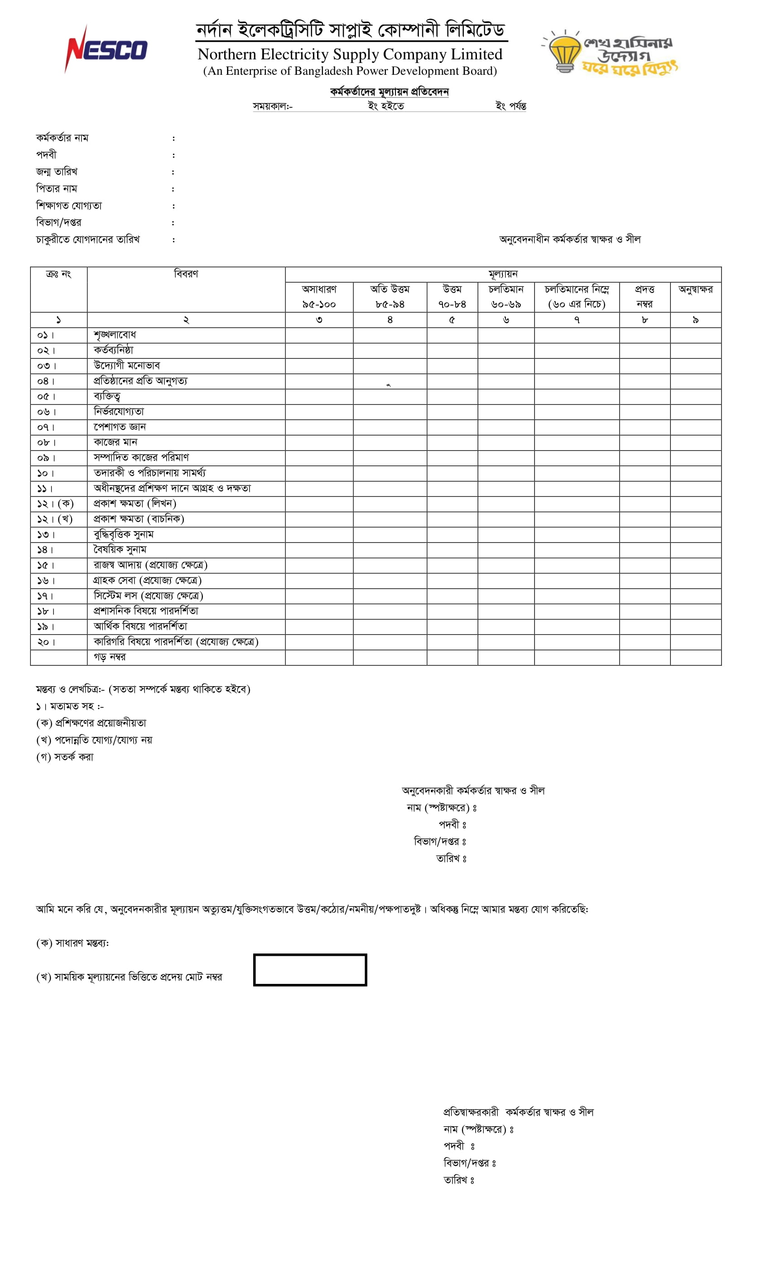Figure 3.2.1.6 contains the officer’s evaluation form.

Figure 3.2.1.6 officer’s evaluation form

**3.2.1.7 Application Form**

To apply for any post in NESCO, this form is filled up by the applicants. This form contains the details of the applicants about his personal information, educational information and all background.

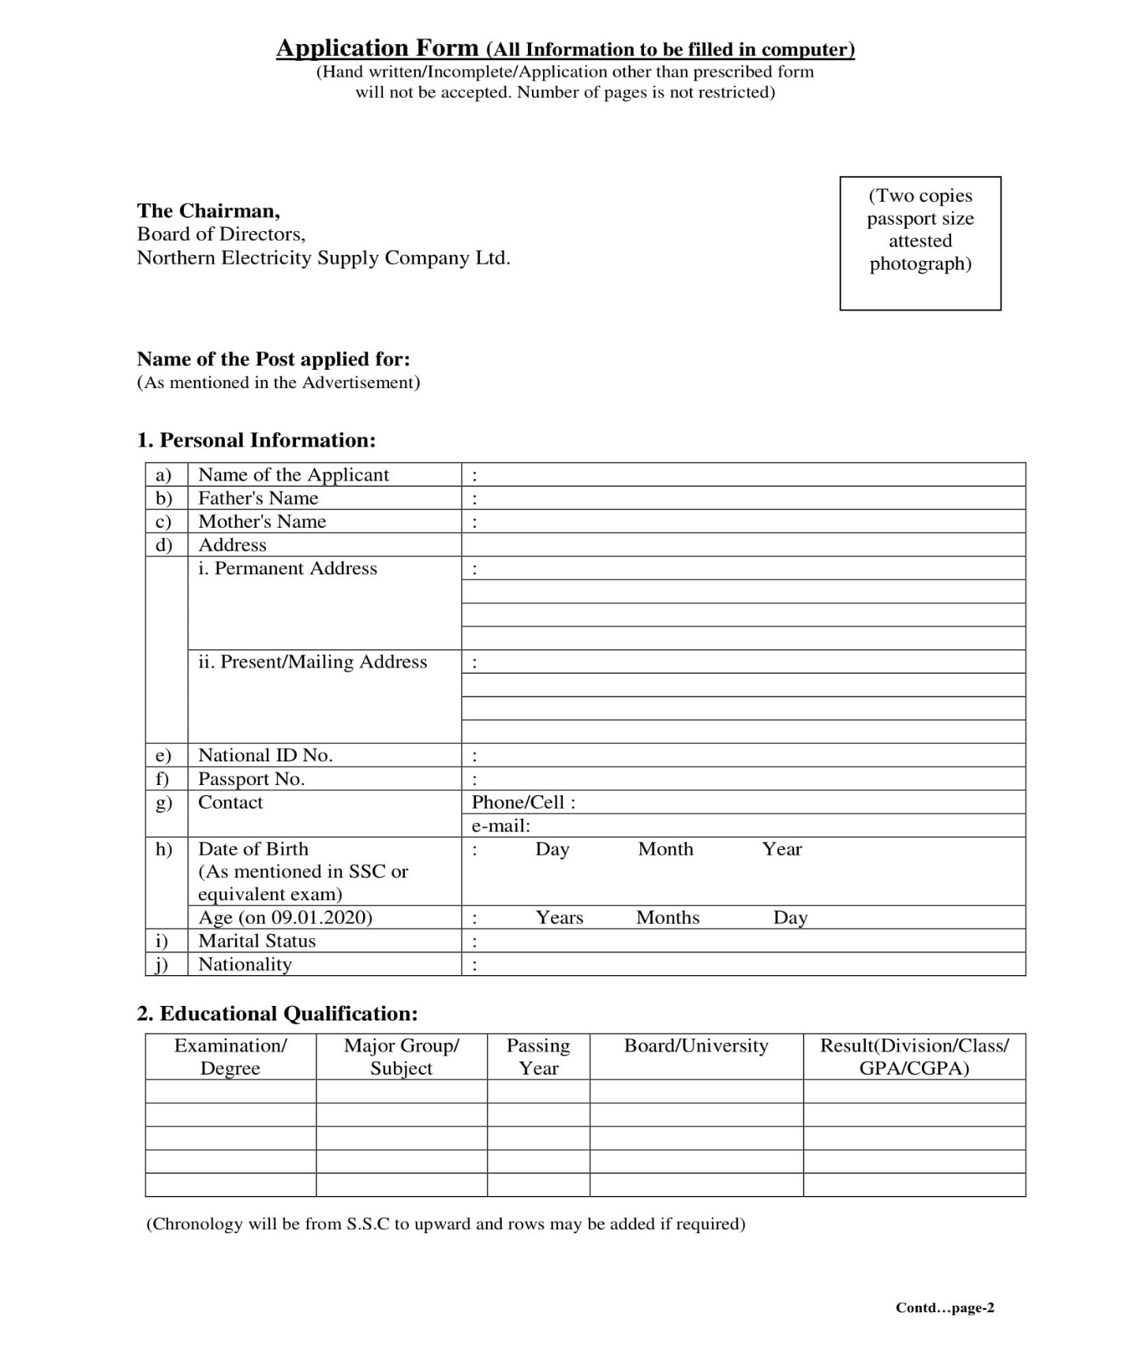Figure 3.2.1.7(a) and 3.2.1.7(b) contain the application form.

Figure 3.2.1.7(a) application form



Figure 3.2.1.7(b) application form

**3.2.1.8 Load Calculation document**

This form or documents helps to calculate the load to which power is distributed. Actually, this form is filled up by the contractor.

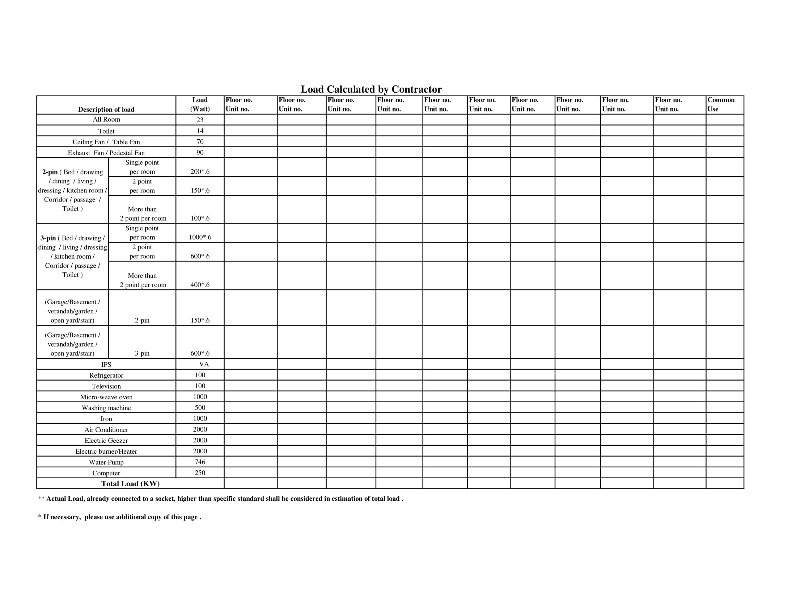Figure 3.2.1.8 the load calculation by contractor.

Figure 3.2.1.7(a) application form

**3.2.2 Onsite observation on working process of NESCO**

Onsite observation is one of the main tools of information gathering. By this process the real system can be visualized more clearly and can be got attached with the system which opens the door to know more about the system. The observer should be experienced and intelligent enough to focus on the working procedure and gather information. For this, he or she should keep in mind the following questions.

* What kind of system we are observing.
* The people running the system and who are important people of the system.
* The history of the system and the evolution of the system to current stage.
* How the system responses to internal and external crisis.

Before observation, the observer should know about different types of observation. Among them four alternative observation methods are used usually.

* **Natural or Contrived**

In natural observation, the observation takes place in the employee’s place or in the system but in case of contrived observation, it is set up by the observer or in a place like laboratory.

* **Obtrusive or Unobtrusive**

In obtrusive observation, the respondent or the person being observed knows that he or she being observed. In unobtrusive observation, the respondent does not know about it.

* **Direct or Indirect**

In direct observation, the observer directly observes the subject or system but in case of indirect observation, an intermediate mechanical device like recorder or camera is used to observe.

* **Structured or Unstructured**

In structured observation, the observer actually records or gather information of a particular or specific action but in case of unstructured observation, the observer observes whatever are pertinent or visible to him at the time of observation.

We have observed the system several times and our observations were natural, obtrusive, direct and unstructured. Some of the observations are detailed below-

1. During our observation, we found that all the employees are busy with there work. We met with the deputy general manager. He was also busy and involved in an online meeting with the officials. He was very cordial to talk with us. he asked us about our need. Then we inform him about the report and sked different questions. He answered clearly and gossip with us. during that period also, the employees came to him for different directions and he directed them.
2. We also observed the office thoroughly and they showed us their personal server. It was highly secured and the doors were secured by finger print of the employees only. They showed us their whole server system including the power supply to the servers, cooling systems, the chambers, the large CPUs, large memory device etc. One employee was constantly working in the control room to observe all the time whether any fault is aroused or not.
3. We again observed the supply system and the large machineries of the system. The liable person was there to control the system. All the employees and officials were busy with their respective works. But they have a deficiency in manpower. As there was not required manpower to control the whole system, the appointed persons were so busy to handle all the works properly. ICT department also need manpower as it has started a few years ago but advancing with large progress.
4. All the officials and employees behaved very good with us. they were willingly giving different information about the system when they came to know about our visit. The deputy general manager was also very cordial and gossiped a lot with us. The respected engineer showed us different portions of their server with enthusiasm and described every little works.